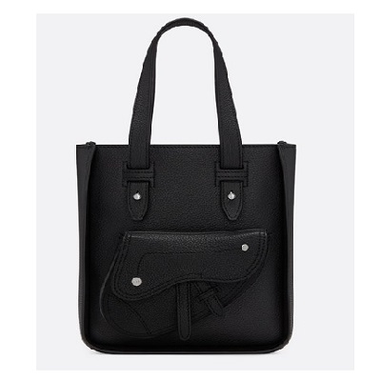

Saddle tote in black calfskin

PRODUCT DETAILS

**Heat-embossed "Dior" logo on the inside**

**1 outer flap pocket**

**Removable and adjustable shoulder strap in black grained calfskin**

**Carried in the hand or on the shoulder**

**Made in Italy**

**19.5 x 23 x 5.5 cm**